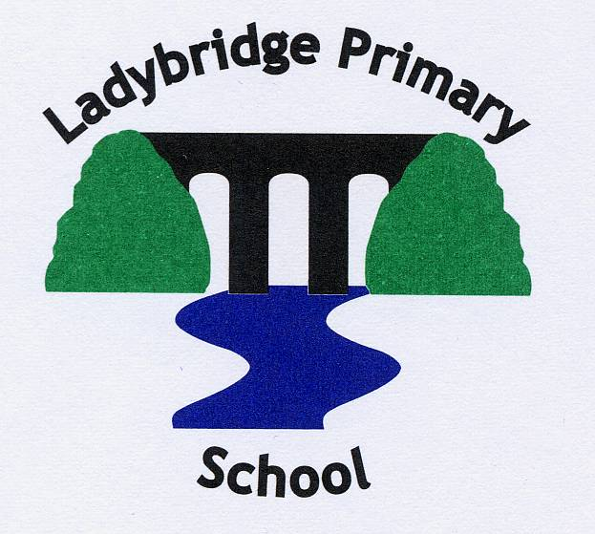
Ladybridge Primary School Relationships and Sex Education (RSE) Policy
September 2020, updated summer 2022

Intention
It is our intention that relationship education has a high priority at Ladybridge Primary School; children will have safe and effective lessons that are age appropriate for primary aged children. Relationship education will be embedded in the school core values of aiming high, resilience and respect and will help everyone to achieve the school motto “Be the best that you can be”.
Implementation
The Governing body, SLT and school staff will ensure that the policy is active, visible and understood by themselves, children and families. Families will be invited to information events about the content of the curriculum to ensure that they understand that RSE is a curriculum about health and wellbeing; relationships and living in the wider world. It will be deeply integrated within the Personal, Social and Health Education (PSHE) of all our children. We ensure that RSE is inclusive and meets the needs of all our pupils. Support will be provided for vulnerable children and adults as needed.
Impact
Children will be able to build and maintain positive and healthy relationships. They will know how to look after themselves and each other and have a sense of being happy in their own skin. Children will be well prepared for, the opportunities, responsibilities and experiences in later life. Children will have a sense of their own and others moral, spiritual, cultural, mental and physical development.

Teaching and Learning
We are required to teach Relationships education, RSE as part of the PSHE curriculum. The Department for Education states that from September 2020 all primary schools must deliver relationships education.
Teachers and support staff will apply the principles of good teaching as set out in the teaching and learning policy.
Scheme of work
The Ladybridge curriculum ensures that every child is guaranteed a PSHE education that covers mental health and wellbeing, physical health (including healthy lifestyles and first aid) and learning about safe, healthy relationships, including understanding consent and negotiating life online. The curriculum includes vital non-statutory content such as family sessions to build relationships, friendship groups, forest schools, restorative approaches and economic wellbeing and careers education. At Ladybridge we use a planning matrix, (the content will be reviewed annually as part of the planning cycle) see the appendices.
Planning
Every class will have Weekly restorative circles, the planning matrix will be used to generate themes and Learning Intentions; the Headteacher will take an assembly each Monday with a related theme, all classes have an additional lesson during the week to ensure that all aspects of the curriculum are covered and that children have a clear sequence of progressive lessons.
Sex Education
Statutory requirements state that schools do not have to teach sex education at KS1 and 2 other than the biological/reproductive aspects that they are required to cover in science. However, at Ladybridge we have a sex education programme that is tailored to the age and physical and emotional maturity of the pupils. The sex education will take place during years 6, preparation leading towards sex education will take place in years 4 and 5 i.e. children learning about how bodies change during puberty – not sex education. All planning is available on the school website and in the appendices to this policy.
Information for parents
Parents have been consulted as part of the development of this policy. There will be an Annual information evening where parents will have access to the content of PSHE, and relationships education including sex education. This is to inform and reassure parents.
Parents and Carers have the right to withdraw their child from sex education but not from statutory Science, Relationships Education or Health Education. At Ladybridge if a parent requests that their child is withdrawn from sex education they will have a lesson in a different class.
Further information for parents can be found on the school website and by clicking on the link below.
https://www.pshe-association.org.uk/pshe-education-guide-parents
Monitoring, Evaluation and Standards
RSE will be monitored by the Subject leader for PSHE, this is currently Helen Parker. She will carry out work samples, pupil voice, planning scrutiny and planning sampling to ensure that RSE is being taught well in all classes.
Teachers will use the planning matrix to assess children’s understanding of relationship education, this will be reported termly to the SLT and Governing Body.
Special Educational Needs
As part of our inclusive practice Teachers employ strategies to support children with SEND; strategies such as adapting the content of a session to support the child’s developmental maturity; the differentiation of activities, resources, specific adult support for children and expectation of outcome.
Professional Development
Staff will have resources such as Learning Leads and the PSHE Association signposted, in addition to this there will be staff meeting time as needed. The Governing Body will be invited to an annual twilight meeting.
Equal Opportunities
We believe that Relationship education is the entitlement of all children irrespective of ethnic origin, gender, social background, sexual orientation or ability and we strive to ensure that all children are treated and supported equally to achieve their potential. Information is provided on our website in a number of languages and we use an interpreting service for parents who may have questions that need to be answered in their home language.
Date of last review: 6th October 2020
Date of next review: 11th July 2022

Head Teacher’s signature: Emma Hill

Chair of Governors’ signature: Prof Nick Silikas

Appendix 1 Whole school overview
Appendix 2 Year group overviews - Year 1
Year 2

Year 3

Year 4

Year 5

Year 6

